Exercise: Shell scripts

1. Write a shell script to get the current date, time, username and current working directory.

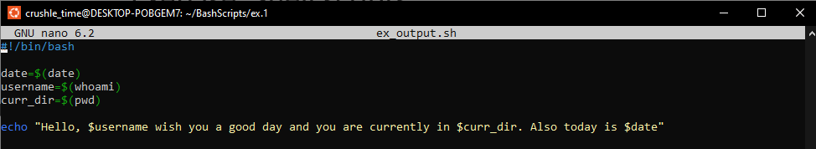



2. Write a shell script that prints “I love learning about DevOps” on the screen. Message should be a variable.

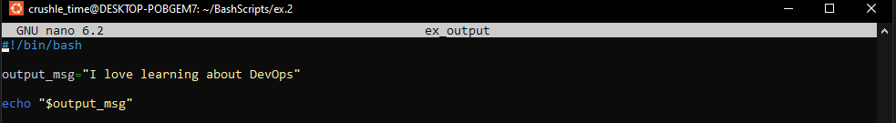



3. Write a shell script that displays “plan code build test release deploy” on the screen with each appearing on a separate line.

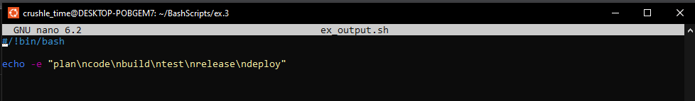

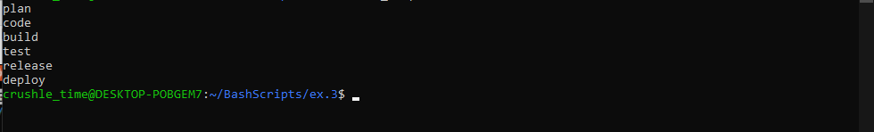

4. Write a shell script that prompts the user for a name of a file or directory and reports if it is a regular file, a directory, or another type of file. Also perform a ls command against the file or directory with the long listing option.

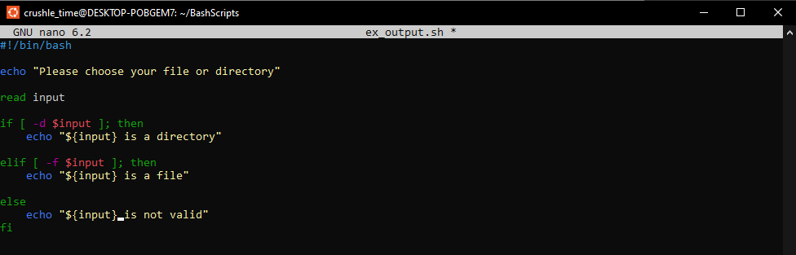

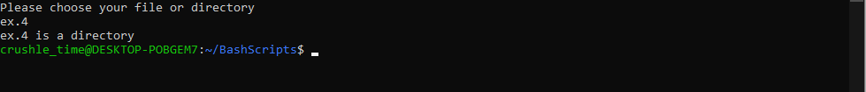

5. Use arguments in a script. Total number of arguments should be three.

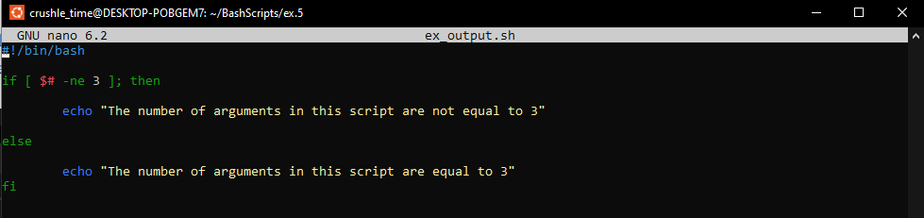





6. Write a script that till output your name out of a variable and will display the server uptime

